**Through-hole** technology (also spelled "thru-hole"), refers to the mounting scheme used for electronic components that involves the use of leads on the components that are inserted into holes drilled in printed circuit boards (PCB) and soldered to pads on the opposite side either by manual assembly (hand placement) or by the use of automated insertion mount machines.

Two types of symmetry of through-hole components: axial (top) and radial (bottom).

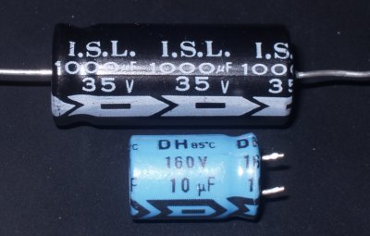

**Surface-mount technology** (SMT) is a method for producing electronic circuits in which the components are mounted or placed directly onto the surface of printed circuit boards (PCBs). An electronic device so made is called a surface-mount device (SMD).

In industry, SMT has largely replaced the THT construction method. Both technologies can be used on the same board, with the through-hole technology used for components not suitable for surface mounting such as large transformers and heat-sinked power semiconductors.

Packaging

<https://www.diodes.com/design/support/packaging/diodes-packaging/diodes-package-outlines-and-pad-layouts/>

|  |  |
| --- | --- |
| TO-92  Transistor outline  Used for transistors, temperature sensors | |
| https://upload.wikimedia.org/wikipedia/commons/thumb/9/92/TO-92_Back_with_Pin_Numbers.svg/800px-TO-92_Back_with_Pin_Numbers.svg.png | https://upload.wikimedia.org/wikipedia/commons/thumb/0/0a/TO-92_Front_with_Pin_Numbers.svg/800px-TO-92_Front_with_Pin_Numbers.svg.png |

|  |  |
| --- | --- |
| TO-220  Transistor outline  Used for transistors, voltage regulators | |
| File:TO-220 Front Coloured.svg | File:TO-220 Back Coloured.svg |

|  |  |
| --- | --- |
| SOT23-*n* (SOT23-3, SOT23-5, SOT23-6…n)  Small-outline transistor  Usied for transistors, diodes and voltage regulators | |
| https://upload.wikimedia.org/wikipedia/commons/e/ed/SOT_23%2C346%2C323%2C416_OK%C3%93TOVAN%C3%BD_N%C3%A1RYS_K_NAHR%C3%A1T%C3%AD.png | https://upload.wikimedia.org/wikipedia/commons/5/58/SOT23%2C346%2C323%2C416_voln%C3%BD_pohled.png |
| https://upload.wikimedia.org/wikipedia/commons/f/fb/SOT_353_-_OK%C3%93TOVAN%C3%BD_N%C3%A1RYS_K_NAHR%C3%A1T%C3%AD.png | https://upload.wikimedia.org/wikipedia/commons/1/17/SOT353_voln%C3%BD_pohled.png |

|  |  |
| --- | --- |
| DIP*n* (DIP4, DIP6, DIP7, DIP8...n) | |
| Image result for dip64 |  |

|  |  |
| --- | --- |
| SO*n*/SOIC (SO4, SO6, SO8...n) | |
| Image result for soic |  |